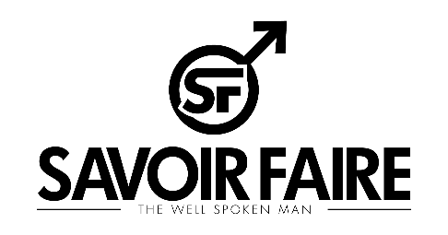
SUBMISSION GUIDE
Thank You for your interested in submitting images and content to Savoir Faire Magazine. This Guide was built to give you guidance on how and what to submit to us for consideration.

Before submitting your images to Savoir Faire Magazine here are a few things you should know.

- We do not compensate for the images we publish in our publication
- We are distributed in digital and in print formats
- We are sold on platforms like Amazon, Google Play, iTunes, Magzter and Joomag
- Savoir Faire is on Twitter, Instagram and Facebook.

When Submitting to Savoir Faire Magazine please be sure to follow this checklist to ensure your submission is considered. Any submission missing anything on this list will not be excepted.

- All photos must be high resolution (150 DPI or more)
- No photography watermarks can be on any images submitted to us.
- No other marks or signatures can be on any of the images submitted.
- You must have permission or own the rights to submit images to us and prove it with a filled-out photography release form.
- When you submit your email in the heading of the email write “Submission for Models Name”
- In the body of the email you must include the photographers name, the models name, the name of the brands featured in the images and any other credits that should be published.
- All submissions must be submitted via email at savoirfairemag@gmail.com

